CLIENT INTAKE FORM FIRST ATTUNEMENT

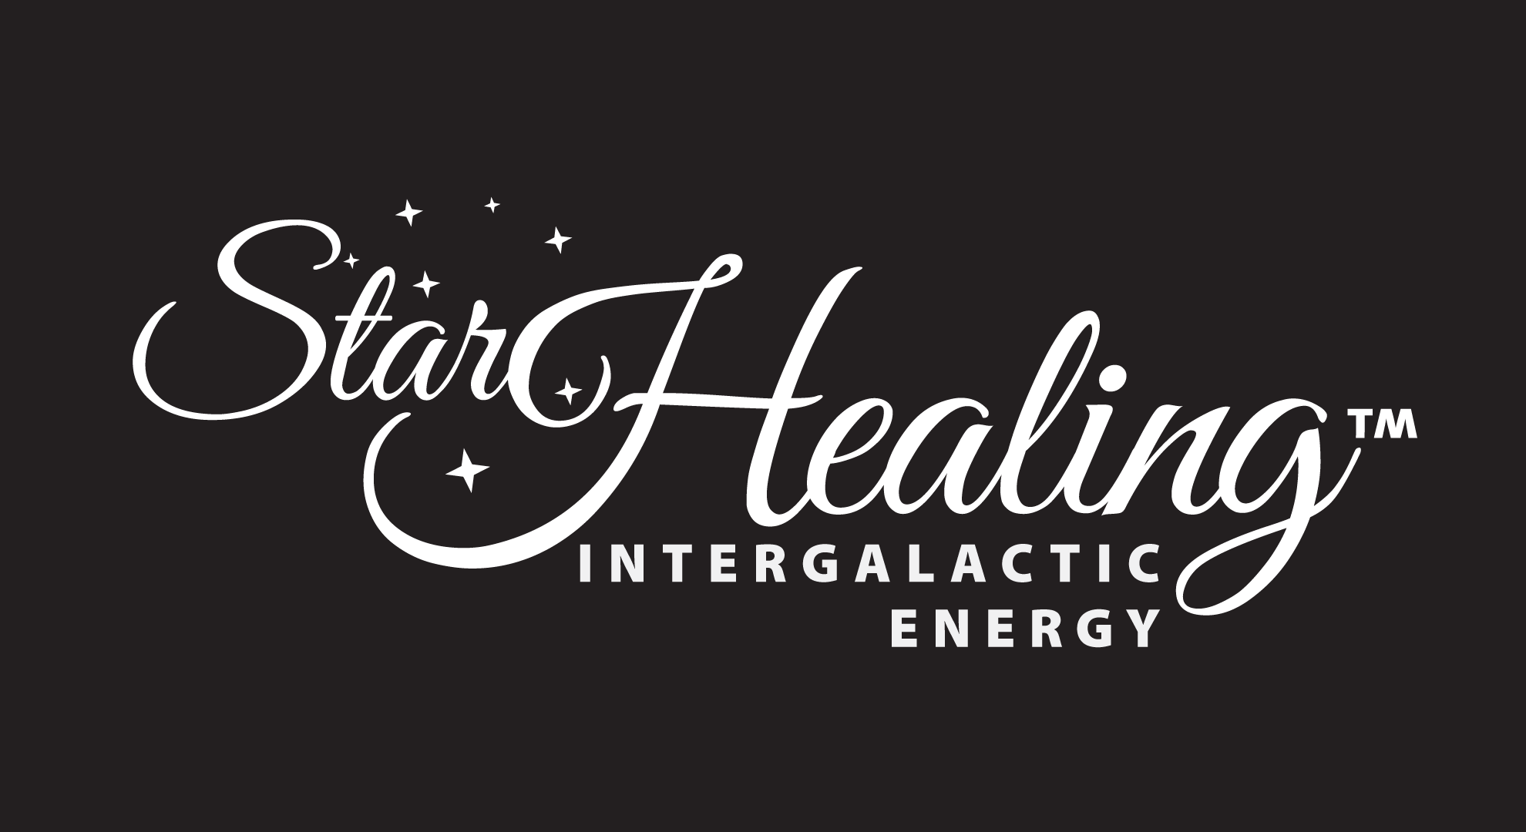

STAR HEALING INTERGALACTIC ENERGYTM SESSION
For Kelly Hampton, Certified Practitioner (“Certified Practitioner”) of Healing Enterprises, LLC
Updated May 2014/Since 2010 “The Healing System for 2012 and Beyond,”—Archangel Michael

Date of Session(s): _____________________________
Name: ______________________________________________________________Age_______________________
Street Address___________________________________________________________________________________
City: _____________________________ State/Area___________________________Country___________________
Zip/Postal Code: _______________________
Payment Method: ____ Cash _____ Check _____Credit______________Paypal _______________________________
Email: ________________________________________________________Phone: ____________________________
Skype: ___________________________________
Who can we kindly thank for referring you to Star Healing Intergalactic EnergyTM? ____________________________________________________Contact: __________________________________
May we give you Frankincense or Lemon Oils during your session? (Will be done remotely if not in person session) yes____________________________________________ no ____________________________________________
Any known medical conditions? Please describe: ____________________________________________________________________________________________________________________________________________________________________________________________________________________________________________________________________________________________________________________________________________________________________________________________________________________________________________________________________________________________________________________________________Are you depressed or sad or grieving?_____________________________________________________
Do you presently have or ever had suicidal thoughts?__________________________________________
Any fears/phobias/compulsions or addictions you would like to be released? ________________________________________________________________________________________________________________________________________________________________________________________________________________________________________________________________________________________________________________________________________________________________________________________________________
Any allergies? Grinding teeth? Eye, ear, nose conditions? If so, please describe the severity of them and any other information you feel will assist your practitioner: ____________________________________________________________________________________________________________________________________________________________________________________________________
__________________________________________________________________________________________________Are you sleeping well most nights? __________________________________________________________________________________________________
Are you currently taking any medication? If so, for what condition(s)? ______________________________________________________________________________________________________________________________________________________________________________________________________________________________________________________________________________________________________
Have you had any joints replaced / any foreign stints or other artificial objects in your body? If so, please describe. ______________________________________________________________________________________________________________________________________________________________________________________________________________________________________________________________________________________________________
Do you presently have any pain in your body? If so, where it is located and would you classify it as mild/chronic/severe?_____________________________________________________________________________________________________________________________________________________________________________________________________________________________________________________________________________________ __________________________________________________________________________________________________
Any other information that you feel would benefit your practitioner including any history of sexual, physical or severe emotional abuse? A history of substance abuse? Are you presently in any treatment program?____________________________________________________________________________________________________________________________________________________________________________________________
Are you the recipient of an organ donor program? _________________________________________________________
Do you have any mind conditions? ADHD/OCD/panic attacks? Anger issues? Forgetfulness? Alzheimer’s etc.? _____________________________________________________________________________________________________________________________________________________________________________________________________________________________________________________________________________________________________
Have you had other energy healing sessions? When was the last one? If so, please describe: _________________________________________________________________________________________________ _________________________________________________________________________________________________
The thought energy in homes are vitally important to elevate to extend your healing and create prosperity. Toxins are created by any/all thoughts like loneness, pain, boredom, anxiety, frustration. Etc. To amplify your Star healing benefits and create all forms of abundance Archangel Michael’s Ascended SpacesTM, the companion Ascension home space system is recommended. To order the guide book or to become a certified practitioner visit www.kelly-hampton.com
How much joy is in your home presently? _____________________________________________________________

TESTIMONIAL USEAGE: ________Yes, consider this initial my agreement to model release (photo) to use my image. ____________Yes, you have my agreement to use my written or verbal testimony.
I am presently interested in receiving all forms of testimony including audio testimonies via smart phones. Please kindly send to Kelly@kelly-hampton.com ________No, I would rather not at this time.
RECORDING OF YOUR SESSION IS PROHIBITED. We kindly ask that you remove any crystals or other gem jewelry during your session. You may wish to have a blanket handy also as temperatures can change in a healing session. You may also wish to play clear quartz crystal sound to elevate your session if you home is not presently being elevated using Ascended SpacesTM. We kindly ask that no other people accompany you during your session. Occasionally, certain conditions may actually worsen after a session temporarily. Recording of your session is prohibited. We reserve the right to refuse healing on anyone who has a pace maker, is an organ donor recipient or who is intoxicated.

*** The above information is true and correct to the best of my knowledge. I understand that the alternative practice called STAR HEALING INTERGALACTIC ENERGYTM is not regulated as a medical practice, nor is licensed by the state, territory, possession, country, or other jurisdiction. This healing modality does not require physical contact and, therefore, does not require a license in the state of Missouri. Healing Enterprises, LLC and its Certified Practitioners are not licensed physicians and do not diagnose, treat, cure or prevent any illness, disability, or affliction, whether physical or mental. Do not suspend or avoid your prescribed medical treatments without consulting your physician. You are solely responsible for continuing your own medical treatment and care. Completion of your Star Healing Intergalactic Energy session does NOT qualify you to teach Star Healing Intergalactic EnergyTM sessions. Email us at Kelly@kelly-hampton.com or visit www.kelly-hampton.com if you would like to receive additional information on how to become a certified practitioner. Kelly Hampton is a master practitioner and the only person authorized on behalf of Healing Enterprises, LLC to teach the Star Healing Intergalactic EnergyTM to practitioners. If you become aware that someone else is presenting workshops in this healing modality, please notify us at Kelly@kelly-hampton.com. I release the Certified Practitioner, Healing Enterprises, LLC and its’ employees and managers from all liabilities and claims of any kind arising from this session, whether known or unknown and whenever occurring. We reserve the right to decline treatment if you are under the influence of drugs or alcohol. Use of medical drugs may limit the full potential of your healing session.

By signing below, I acknowledge and fully agree with the above information and grant permission to treat.
Signature of Client: _______________________________________________________________Date: ____________
If a minor, signature must be of parent or guardian
Signature of Certified Practitioner: _______________________________________________________________________________________________
Email and phone of Certified Practitioner: _______________________________________________________________
Date of first year recert: ________________________________________________________

Copyright by Healing Enterprises, LLC, 2011. For more information, please visit www.kelly-hampton.com11891-0111: Healing Enterprises, LLC/General: 400092 updated May. 2014.

